RTi: Interventions That Work!
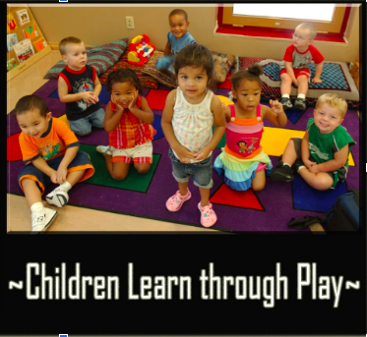
Presenters:
Dr. Elizabeth Betebenner, SLP
Connie Wilkinson, School Psychological Examiner

MO-CASE Fall Conference
September 22-24, 2019

Missouri Department of Elementary and Secondary Education Statements:
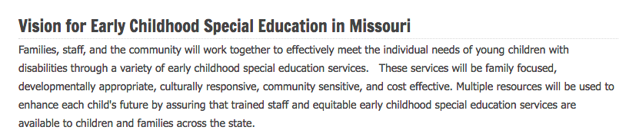
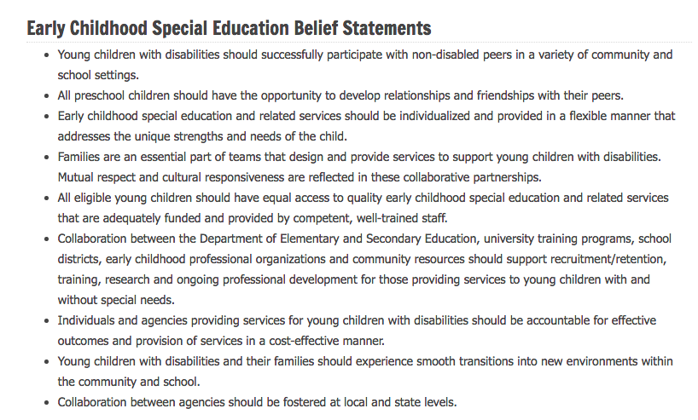

The Special Education Referral Process: 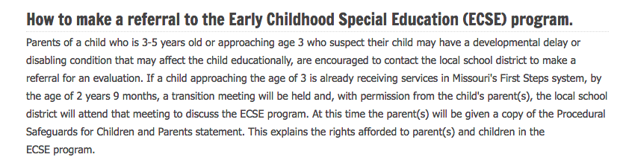
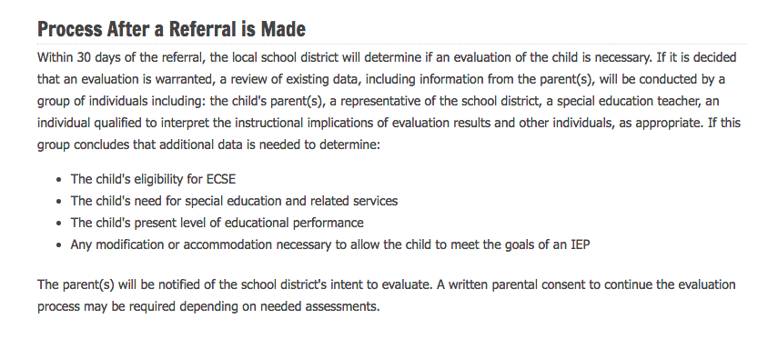

At Joplin Early Childhood, a PST (Problem Solving Team) consisting of the school psychological examiner, speech pathologist, physical therapist, occupational therapist, behavioral specialist, a general education teacher, and a special education teacher, and others as needed, review the referral information contained in the Referral Request Form, and gather any additional information as needed, to determine if the concerns warrant an evaluation at the time of referral. Interventions which have been implemented in the classroom and results of these interventions assist in determining if concerns are significant enough to warrant an evaluation for special education services.

Social/Emotional/Behavioral Developmental Milestones
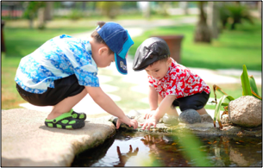
By age 3, children should be able to:
- Begin to develop social interactions with peers (friendships)
- Begin to develop social interactions with adults other than parents
- Interact with peers in more complex ways than the toddler years
- Sustain play with other children for longer periods of time
and are expected to have conflicts with peers (even more with friends as they spend more time together)
- Demonstrate more prosocial behaviors (sharing, caring, helping)
- Be less likely to have tantrums or outbursts when frustrated
- Demonstrate relational aggression to express feelings (being mean, excluding)
- Begin to develop a sense of self (who they are)
- Be strongly influenced by adult feedback (both positive and negative)
- Begin to recognize and name emotions

By age 4, children should be able to:
- Express more complex social emotions with facial expressions, gestures, words (pride, guilt, shame)
- Describe and label feelings
- Identify feelings of others and start to consider why they may feel that way
- Express their anger or distress in more acceptable ways
- Demonstrate consideration for others, conscience
- Demonstrate some self-regulation/self-control of impulses
- Develop inner sense of right and wrong (four year olds may interpret social situations in overly negative ways - this is to be expected)

Social/Emotional/Behavioral Developmental Milestones (continued)

- Demonstrate an increasingly complex awareness of others’ feelings, show concern
- Begin to learn to cope with/manage stress (anxious, angry)

By age 5, children should be able to:
- Share, care, give (five year olds naturally enjoy giving and receiving!)
- Express social emotions for the most part effectively and appropriately
- Internalize values and expectations for behavior (grasp the concept of rules)
- Identify their own feelings accurately and state why they may feel this way
- Self-regulate anger and distress most of the time in acceptable ways
- Refrain from overly aggressive behaviors and/or reactions
- Develop closer, more intimate friendships with select others
- Try new things willingly (five year olds may be assertive of their own preferences)
- Participate in more complex, interactive play, often with roles assigned

Social/Emotional/Behavioral Developmental Milestones (continued)

Social/Emotional/Behavioral Interventions

- Provide activities which encourage play and interaction, with increasingly complex levels of interaction (water play, shaving cream, bubbles, work on a large piece of paper on the floor or table where children can draw/color with others and “create” together)
- Provide individual support for children who need support/modeling to appropriately interact while working/playing beside other children
- Determine individual children’s interests so activities can be planned which encourage children’s interest
- Have one child engage in a game activity with one peer. With success, gradually increase the size of the group.
- Capitalize on opportunities to share and help (assigned “jobs”, promote problem solving as a class)
- Choose a peer to model appropriate interactions with another student
- Provide redirection in a positive manner
- Use pictures of faces to identify various feelings of others
- Use written stories/books to teach about actions and feelings
- Maintain a consistent, dependable, predictable schedule
- Allow child to choose a group of peers with whom they feel comfortable
- Use a student’s favorite item to initiate play when a child is having difficulty choosing an area of play
- Provide opportunities for small group participation as opposed to large group participation
- Allow student to be present during group activities without requiring active participation
- Make social situations relevant and accessible - think transition times!

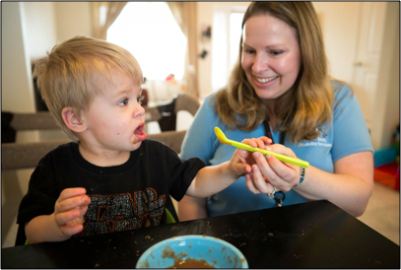

Adaptive Behaviors Developmental Milestones

By age 3, children should be able to:
- Communicate their wants and needs clearly enough so that others who do not know him/her can understand most of what is said
- Look at others’ faces when they are talking to him/her
- Say phrases with at least two words
- Point to at least one body part when ask
- Select a book and turn pages in a book
- Pick up toys
- Wash hands with little assistance
- Transition with support and prompting
- Avoids bumping into walls or objects
- Refrains from eating non-edible objects
- Put on clothing with assistance
- Plays with a variety of toys, alone or beside a peer (onlooker or parallel play)
- Feed self with fingers, may be using a spoon or other utensil
- Tries a variety of food
- Quiet when comforted by others fairly quickly
- Choose an activity when given a choice
- Responds differently to familiar and unfamiliar adults
- Shares toys with some expected resistance
- Greets others appropriately (ie - “Hi!”)
- Toileted with few accidents, requires assistance in restroom at times

Adaptive Behaviors Developmental Milestones (continued)

By age 4, children should be able to:
- Raise and lower their voice to express different feelings
- Use simple sentences
- Respond to their name in print
- Recite a simple nursery rhyme
- Perform simple errand when ask (get item, move to another location)
- Wash hands with no assistance
- Transition with moderate to few concerns
- Tell an adult if they do not feel well/someone is in need of help (peer)
- Put on clothing with minimal assistance
- Play with a variety of toys, interacting with peers (interactive play)
- Feed self with variety of utensils, use open cup w/relative success
- Follow an adult’s request
- Work independently for a short time on an activity (ie - puzzle)
- Share toys and materials with peers with some adult support
- Beginning to show sympathy for others when they are sad or upset
- Toileted, with rare accidents, use restroom w/minimal assistance

By age 5, children should be able to:
- Wait for others to finish what they are saying without interrupting
- Tell another about their favorite activity
- Answer simple questions about a story read to him/her
- Begin to or write some version of their name
- Put things in proper place (clean up) when finished
- Transition with little to no concerns
- Ask a teacher/adult before going near something dangerous
Adaptive Behaviors Developmental Milestones (continued)

- Put on coat/shoes with minimal assistance
- Play with a variety of toys, interacting cooperatively in more complex, role play scenarios
- Eats a variety of foods, use open cup and utensils independently
- Refrain from grabbing a toy from another child
- Stop a fun activity when ask, with minimal complaining
- Share toys and materials successfully with minimal adult support
- State when they are feeling happy, sad, scared or angry
- Toileted with little to no accidents, can use restroom independently

Adaptive Skills Interventions

- Interact frequently with students to help them follow directions, listen and respond
- Plan activities which allow for recognition of feelings
- Read stories utilizing nonverbal facial expressions which must be interpreted
- Use opportunities in the daily classroom routine to practice dressing skills (restroom use with child performing tasks as independently as possible, preparation for going outside or at arrival and dismissal with coat, having dramatic play clothing with fasteners for practice)
- Use snack and meal times at school for practice with utensils
- Plan small group activities that allow for appropriate responses to others, with intentional planning for teaching this skill
- Allow time and have expectations for children to care for their own specific area where their personal belongings are kept in the classroom

Cognitive/General Intelligence Developmental Milestones
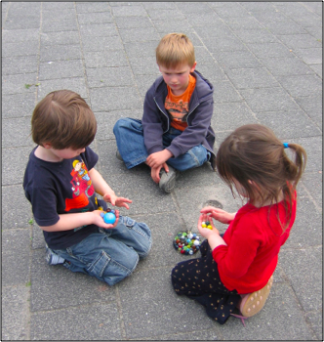
The “preoperational” stage of development,
ages 2 - 7, is the stage where children are less capable in their thinking compared to older children. (Piaget)

Expectations for 3, 4 and 5 years olds in this stage:

- Illogical thinking
- Egocentric thinking (it’s all about them! “Me, myself, and I”)
- One-dimensional thinking (not able to see another perspective)
- Limited capacity to reason and solve problems
- Trouble focusing on details
- Limited memory
- Limited knowledge of conventional knowledge (depending on exposure and experiences)

All learning for young children is interdependent. Cognitive development has important implications for children’s social and language development, and social and language development plays an essential role in stimulating cognitive growth.

Preschoolers narrow focus on a limited amount of information at any given time is actually useful while they are learning so many things so rapidly (Bjorklund 2007).

Preschoolers learn best when they can attend to just one thing at a time, such as putting all the yellow crayons and markers in one bin and purple crayons and markers in another bin. This clean-up activity cements awareness of color.

Much of children’s understanding first occurs in communication with other people, then appears in thinking aloud, and eventually is internalized as thought. (Vygotsky) So, let them talk, a LOT!
Cognitive/General Intelligence Developmental Milestones (continued)

- Make-believe or pretend play with guidance and support from adults (not specific adult-direction)
- Have available a large variety of materials requiring different skills (puzzles, multiple drawing materials, blocks)
- Firsthand, meaningful experiences are likely to help preschoolers understand and remember relationships, concepts and strategies. Plan many, diverse experiences!
- Modeling flexibility and substituted use of objects for items needed in play (using sticks and leaves for the ingredients in soup while on the playground, a block for a cell phone, etc)
- Supporting collaboration with peers for acting out stories
- Pretend play/dramatic play support self-regulation, motivation, perseverance, increased attention span, encourages children to mentally picture different situations and allows them to take control of experiences when they have little control of experiences in real life.
- Everyday associations help with teaching children to naturally organize items (dishes in pretend play cupboard, blocks in baskets)
- Increase the number of mental representations in children’s everyday classroom experiences (a bowl can be a bowl, or a hat, or a bed for a baby mouse)

Fine and Visual Motor Developmental Milestones
 | Fine/Visual Motor Skill I Need to Work On | Mastery Date
 | Stack 1” blocks up to 10
 | Imitate train block design (4 on bottom, 1 on top at end)
 | Imitate bridge block design (2 on bottom with space, 1 on top of both bottom)
 | Imitate wall block design (2 on bottom, 2 on top)
 | Imitate steps block design (3 on bottom, 2 on top, 1 on top)
 | Imitate pyramid block design (3 on bottom with space, 2 on top with space, 1 on top)
 | String 1” beads up to 4
 | Open twist-top lid (size of sprinkle or spice container)
 | Snap (on clothing)
 | Button/Unbutton 1” buttons
 | Zip jacket, including engaging zipper
 | Grasp crayon/pencil with tripod or quad grasp
 | Copy vertical line - age 3
 | Copy horizontal line - age 3
 | Copy circle - age 3
 | Copy cross - age 4
 | Copy X - age 4
 | Copy square - age 4
 | Copy triangle - age 5
 | Cut line - age 3
 | Cut circle - age 4
 | Cut square - age 4
 | Cut triangle - age 4
 | Write 1st name with correct letter formation (top-bottom, left-right)
Fine and Visual Motor Interventions
Stacking
- Use larger blocks for stacking to develop skill/transition back to
small 1” size
- Rubber blocks hold position better - use when struggling to keep
blocks in place
- Use duplo blocks or connecting cups to develop skill and transition
back to small 1” size

Block Designs
- Start simple and add in more complex designs
- Use visual cards as needed - see block design picture card handout

Twist-Top Containers
- Put smaller containers, possibly with thicker lids in kitchen centers -
sprinkle containers are great options!

Fasteners
- 3 year olds should be able to manipulate snaps, ¾” size buttons, and a
zipper on jacket that has to engage - use fastener boards off body,
then try on body
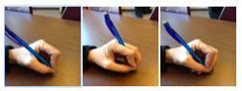
Grasp
- Appropriate grasp patterns
- Use short 1” crayon pieces so that
they can only use thumb and 1st
two finger pads
-Use short 3” pencil to accommodate potential decreased hand strength
and coordination
- Playdoh - roll into “snake” and pinch with thumb and 1st 2 fingers
repeatedly

Pre-Writing/Writing Strokes
- Establish pre-writing skills needed for uppercase letters

Fine and Visual Motor Interventions (continued)

Cutting - see cutting handout for age appropriate template
- Teach hand placement - thumb in small hole, fingers in large hole
- If child struggles to open/close scissors, try springload or loop
scissors
- Try tongs or other dippers to grasp/release to target

Fine Motor Coordination/Strengthening Activities

Regularly do activities to increase upper body and/or core strength which in turn increase fine motor skills include: activities such as reading books, playing games, etc. on tummy (be sure child is resting on forearms, not their chest), crab or bear walking, crawling games, superman (holding position 10-20 seconds), using vertical surfaces to write or draw on such as an easel, marker board on the fridge or wall, taping paper to a smooth surface.

Playdoh/Putty -
Whole Hand - pull putty apart, squeeze together x3-5
minutes
- roll into snake
Fingers - roll into snake, using thumb and each finger by itself, pinch
through putty until able to feel fingers touching
- roll into shorter snake, put ends together to make circle, put finger tips inside circle and open hand to extend fingers
- place small beads in putty and find

Legos - manipulate and create with small pieces

String small beads - may need to make end longer or sturdier for
kids that struggle, can do this by rolling end
in tape

Coins in slot - pick up coins 1 at a time and using fingers and
hand move into palm, holding in place with last
2-3 fingers as picking up more; then one at a time
using hand and fingers move each coin out to
fingertips to put in slot
Fine Motor Coordination/Strengthening Activities (continued)

Clothespins - squeeze with thumb and side of index finger
- squeeze with thumb and first 2 finger pads

Tweezers - using tweezers, pick up cotton balls and place in bowl

Board and card games-have child manipulate small pieces and hold cards to work on development of hands

Sensory Processing Interventions
When children are not able to take in information from their senses, make sense of it, and then use it in their day, they may need assistance with this self-regulation process, so that they can respond appropriately in their environment. Below are some common interventions to help with each sensory system.

Vision
- minimize classroom materials hanging, on shelves, etc
- seat student near teacher, away from frequent visual distractions such as near doorway, at end of table
- turn off classroom lights and use natural light through windows or lamp
- provide personal visual schedule - can use daily schedule, activity schedule – typically kids that need this aren’t able to attend a classroom schedule on a board

Hearing
- use headphones to help filter noisy environments, block loud or startling noises such as bells, sirens, whistles
- use whisper phone for students making noises, humming, singing, etc to self to help register noises appropriately
- prep kids about upcoming drills, sirens, etc when they may encounter loud sounds
Sensory Processing Interventions (continued)
Touch
- provide firm touch rather than light touch that can be startling or alerting

Taste/Smell
- provide appropriate oral input using “chewy” or chewy, crunchy, sour snack when kids are putting nonfood items in their mouth
- minimize air fresheners, perfume, etc when kids are sensitive to smells
- can use alerting fragrances for kids that seem tired or lethargic ongoing

Body Awareness
- encourage student to complete deep pressure activities that provide calming and organizing input, this is recommended every hour and a half-couple hours but can be completed more frequently
- use pressure and/or weighted tools - ie hug vest, weighted vest, weighted blanket/lap pad, weighted animals

Balance and Motion
- encourage student to complete movement activities at an appropriate, designated time so that they are able to sit and attend for a certain activity or amount of time, be sure to follow movement activities with a deep pressure activity to help calm and organize the body - movement is good but can be alerting

How is my body feeling....
and what do I need to do?
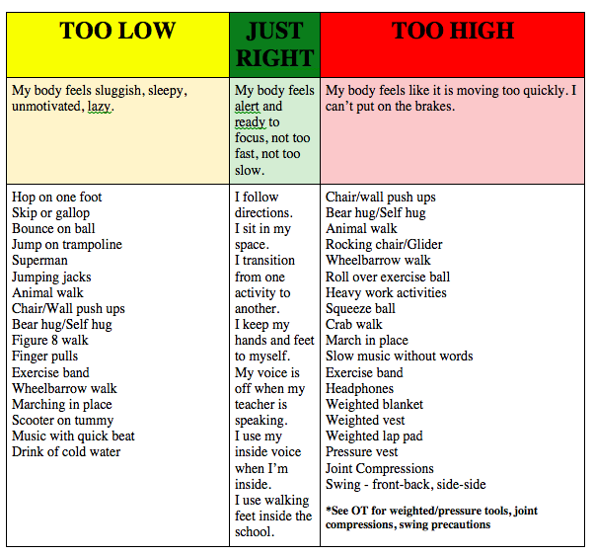

SPEECH and LANGUAGE Developmental Milestones

By age 3, children should be able to:

Receptive Language
Comprehend approximately 1,200 words
Know “in front of” and “behind” when object with a logical front and back are used
Identify hard/soft, rough/smooth
Identify circle and square
Respond to commands involving two actions or objects
Can match colors
Know night and day

Expressive Language
Use/say approximately 800 words
Respond appropriately to simple “how” questions
Can answer two-three questions, “what do you do when you are hungry/sleepy/cold?”
Beginning of question asking stage, mainly asks “what” and “who” questions
Name 8 to 10 pictures
State actions “I ran”
Supply the last word of a line, “the apple is on the…(tree)”
Average sentence length is four to five words
Follow basic commands with prepositional phrases “Put the block under the chair”

Grammar/Syntax
Begin to use “is” at the beginning of a question
Third-person singular present tense is emerging “he runs”
Irregular plural forms emerging (child/children)
Use “are” with plural nouns (boys are running)
Use “and” as conjunction
Use is, are and am in sentences

SPEECH and LANGUAGE Developmental Milestones (continued)

By age 4, children should be able to:
Articulation/Speech
Consonants mastered: m, w, h, p, b
Is approximately 90% intelligible

Receptive Language
Understand approximately 2800 words
Point to red, blue, yellow and green
Identify crosses, triangles, circles, and squares
Can follow a two-part unrelated command
Know most body parts
Understand concepts of numbers up to 3
Answer questions about object’s functions

Expressive Language
Has a spoken vocabulary of approximately 900-2000 words
Has a sentence length of 4-8 words
Talk about experiences at school, at friends’ homes, etc
Ask “who?” and why?”
Begin to use complex sentences
Use contractions such as “it’s a” or “there’s a”
Use grammatically correct sentences
Use regular past tense correctly
Use plural forms correctly
Can relate name and address along with age and gender

By age 5, children should be able to:
Articulation/Speech
Consonants mastered: m, w, h, p, b, n, d, k, f

Receptive Language
Has a receptive vocabulary of approximately 20,000 words
Sequences numbers
Understand ‘left’ and ‘right’
Understand most concepts of time
Understand the meaning of most sentences

SPEECH and LANGUAGE Developmental Milestones (continued)

Expressive Language
Define objects by their uses (“you eat with a fork”)
Ask ‘how’ questions
Answer verbally to “H!i” and “How are you?”
Use past tense and future tense appropriately
Use conjunctions
Name opposites
Sequentially names days of the week
Count to 30 by rote
Count 10 objects
Reduce sentence length to 4-6 words
Exchange information and asks questions
Accurately relay a story
Sings entire songs and recites nursery rhymes
Communicates easily with adults and other children
Uses appropriate grammar in most cases

SPEECH and/or LANGUAGE Interventions and Strategies

What Should I Do for a Child Who…?

Just doesn’t talk much...
Repeat what the child says and add a word that is appropriate to the
context.
Speak in sentences that are just 1 or 2 words longer than the child’s typical utterances. Keep it simple!
Provide opportunities for children to hear appropriate examples of
conversation throughout the day.
Music, movement, nursery rhymes, fingerplays, and book sharing are all motivating times to promote spontaneous speech production.

Speech and Language Interventions and Strategies (continued)

Doesn’t seem to have much vocabulary...
Pre-teach vocabulary before introducing a new story or unit of study.
Discuss the new words and their meanings with your students.
Use visual support—pictures, the written word, and graphic organizers to show the relationship of the target word to other words (antonyms, synonyms, etc.)
Create a Word List using target vocabulary and their definitions and
display it in the classroom. Add to the list as the target vocabulary grows.

Uses incorrect grammar...
When the child says something grammatically incorrect, repeat what the child has said, using the correct grammar. DO NOT call attention to the child’s error in a negative way, simply restate the comment correctly.
When working individually with the child, repeat the grammatical error the child produced and ask if that sounds correct to them. Give the child the opportunity to hear not only the correct form, but also the incorrect form—present as choices and guide the child to eventually recognize from the choices which is the incorrect form.

Says sounds or words incorrectly...
If having the child repeat the error word doesn’t work, try having the child to show you what he/she is trying to say.
If you know what the child is trying to say, repeat the word using the correct sound. Do so without drawing negative attention to the child.
Avoid focusing on the error the child produced.
When providing a model of the correct sound/word, make sure that the is looking at your face and specifically at your mouth.
Try providing verbal choices including the error word and the correct word for the child to select from.

Speech and Language Interventions and Strategies (continued)

Refer to the normative data chart below regarding sound development so you will know which sound errors are typical for children of varying ages.

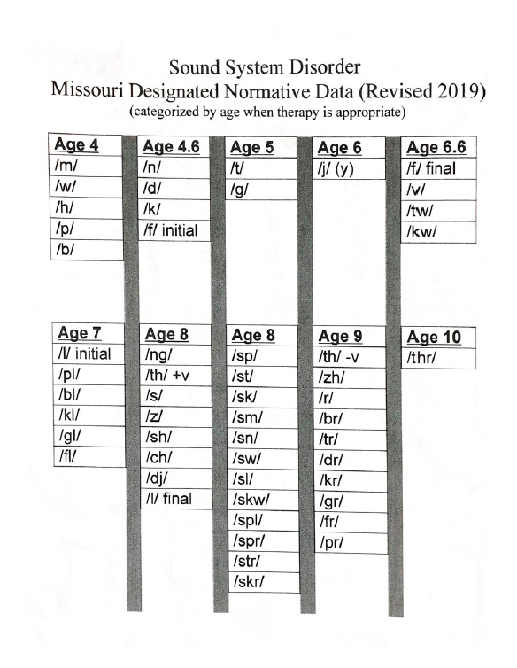

Gross Motor Developmental Milestones
By age 3, children should be able to:
- Walk and run independently
- Walk up stairs reciprocally without support
- Jump with both feet off the floor simultaneously
- Catch a ball tossed to them by trapping it against their body
- Pedal and steer a tricycle

By age 4, children should be able to:
- Balance on one foot for 3-5 seconds
- Walk on a line or balance beam without stepping off
- Walk down stairs reciprocally without support
- Step over obstacles, change direction easily, without loss of balance
- Gallop rhythmically
- Throw a ball forward 10 feet (overhand)

By age 5, children should be able to:
- Balance on one foot for 8-10 seconds
- Hop on one foot 3-5 times
- Jump forward 2-3 feet
- Skipping is emerging
- Catch a small ball with only hands from 5 feet away

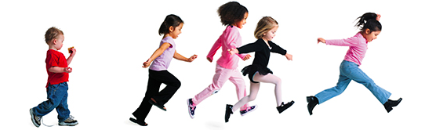
Gross Motor/Functional Mobility Checklist
(Complete ONLY if you have concerns with gross motor and functional mobility skills)

For each item, please circle the response that best describes the child’s ability to perform the skill listed. Please indicate if the child requires an assistive device (wheelchair, walker, orthotics, etc) to complete any of the skills listed below.

Functional Mobility Skills
1) Child is able to walk alone.
Able With Help Unable
2) Child is able to navigate uneven surfaces and/or step over obstacles.
Able With Help Unable
3) Child is able to walk up and down stairs without railings.
Able With Help Unable
4) Child is able to run well without falling or loss of balance.
Able With Help Unable
5) Child can use playground equipment (climbers, ladders, slides).
Able With Help Unable
6) Child is able to pedal and steer a tricycle.
Able With Help Unable

Gross Motor Skills
1) Child is able to jump in place, with both feet off the floor simultaneously.
Able With Help Unable
2) Child is able to kick a stationary ball forward when prompted.
Able With Help Unable
3) Child is able to catch a large ball that is tossed to him/her by a partner.
Able With Help Unable
4) Child is able to balance on 1 foot for a few seconds without support.
Able With Help Unable
5) Child is able to walk backwards without falling or loss of balance.
Able With Help Unable

Gross Motor RTI: Interventions/Activities and Instructional Tips

1) Toe Walking: This type of walking pattern is observed when a student walks on their toes with their heels lifted. It may or not be consistent.

Interventions and Activities:
- Backward walking- use large steps and use heel-toe pattern
- Heel walking- walk up on heels and don’t let toes touch the floor
- Heel-toe walking- exaggerate perfect walking
- Walking up an incline- keep feet flat on surface of incline
- Scooter board (sitting)- use feet to pull self forward, digging heels into the floor as they propel
- Duck walking

Instructional tips:
- Consistent reminders- encourage appropriate technique each time the student is noticed to be walking on toes
- Use a consistent verbal cue (“heels down”, “heels and toes”) so that students can develop appropriate responses to self-correct
- Self stretching techniques can be taught to student/staff by therapist if appropriate

2) Decreased Balance: In a school setting, difficulties with balance may be observed when walking within the classroom, in the hallways, playing on the playground or walking up/down stairs.

Interventions and Activities:
- Practice walking forward/sideways/backwards on balance beam or line taped on the floor
- Practice standing on one foot without support
- Tandem balance (one foot directly in front of the other)
- Jump on trampoline

Gross Motor RTI: Interventions/Activities and Instructional Tips (continued)

Instructional tips:
- Limit clutter on floors, clear a wide path for students to walk
around/between desks and to/from doorways
- For stairs, instruct students to use a step-to-step pattern, then progress to alternating step pattern. Use railing when appropriate.
- Supervise and use judgment for which equipment is appropriate

3) Decreased Ball Skills: Development of ball skills includes higher level coordination, strength, and hand-eye coordination. It also encourages students to cross the midline. Not every student is athletic, however, the foundational skills mentioned above are important for independent and functional mobility.

Interventions and Activities:
- Encourage ball skills during recess or free play time
- Practice tossing paper wadded into balls into the trash can
- Play circle games like hot potato
- Toss bean bag or other small toy to students when you want to have him/her answer a question; have them toss back to you when complete

Instructional Tips:
- By the age of 6, most ball skills should be emerging, including
alternately dribbling a ball
- Lighter, larger balls are easier to catch and throw
- Many students are afraid of catching and will flinch as the ball
approaches; this should improve with repeated exposure
- Make accommodations for students with vision impairments
(example: using a brightly colored ball)
- Balls with texture are often more appealing for students who are not interested in ball skills

Gross Motor RTI: Interventions/Activities and Instructional Tips (continued)

4) Decreased Body Awareness: Decreased ability to know where one’s body is in space. This may be an underlying issue if the student is observed falling out of his/her chair, bumping into walls or people, etc. Impairments in this area can also lead to decreased fine and gross motor planning.

Interventions and Activities:
- Jumping jacks or other jumping activities
- Animal imitations/walking (bear, crab, duck, etc)
- Wall push-ups
- Carry heavy objects (stack of books, weighted ball, etc)
- Erasing whiteboards, cleaning desks
- Push/pull activities (pull another student/staff on a scooter, etc)
- Encourage climbing playground equipment

Instructional Tips:
- Activities that promote body awareness (above) can be done with the whole class as a “warm-up” for the day or specific lesson
- Weighted vests or lap blankets can be used during times when
students are to remain seated

5) Difficulty Sitting Still: Students may have difficulty staying seated and attending to task during lessons. These strategies are intended to increase proprioceptive input, thus providing a calming and organizing effect on the student’s nervous system.

Interventions and Activities:
- Tie theraband to chair legs to allow student to kick or push/pull with feet
- Utilize a wiggle seat or dyna disk for student’s chair or spot on the carpet to allow some movement while seated

Gross Motor RTI: Interventions/Activities and Instructional Tips (continued)

- Allow student to sit on small therapy ball during work time or stand at their desk as long as it is not disruptive to other classroom activities
- Provide opportunities for heavy work (push/pull, heavy carry, log rolling, etc)
- Allow frequent stretch/movement breaks
- Provide fidgets or utilize weighted blanket/vest as appropriate

Instructional Tips:
- Use a soft voice and limit excess auditory stimuli; decrease visual distractions and remove unnecessary visual stimuli
- Have different areas within the classroom where students can work in various positions: lying on stomach, standing or kneeling at easel, sitting backwards in chair, etc.
- Provide student with appropriate seating arrangements (close to teacher, away from distracting peers)

6) Difficulty Climbing Stairs: This activity requires the utilization of a number of different skills such as strength, motor planning, coordination, timing, proprioception, visual perception and vestibular functioning

Interventions and Activities:
- Play games to develop gait patterns: walking on heels/toes, walking backwards, walking sideways
- Play games involving balance: hopping on one foot, marching,
balancing on one foot
- Encourage students to use a variety of equipment on playground including stairs and ladders

Instructional Tips:
- Encourage a step-to-step pattern initially
- Encourage holding onto hand rails when available

Gross Motor RTI: Interventions/Activities and Instructional Tips (continued)

- Work on descending stairs first (easier); once students master this skill, focus on ascending stairs (harder)
- Be sure students are focused on task (not distracted by other
students, not carrying anything in their hands, etc)

7) “W” Sitting: This is a sitting posture in which the student’s bottom is between their legs on the floor with feet pointed out to the sides, creating a “W” pattern. This is NOT the same as a student sitting on their heels with the tops of their feet on the floor (kneeling).

Interventions and Activities:
- Encourage other positions (side sitting, criss-cross, etc) and have students reach for toys to facilitate trunk rotation
- Climbing/squatting activities to strengthen hip muscles
- Therapy ball activities to strengthen core muscles and facilitate rotation

Instructional Tips:
- Consistently correct them when observed “W” sitting and encourage another position
- Use a consistent verbal cue (“fix your legs”, “criss cross”) so that students can develop an appropriate response to self-correct

Helpful Forms for Collecting Data

Interventions Tried and the Results:
Please include a description of interventions (things you have tried in any setting to increase success), dates, how often and how long, and the results of each intervention.

- Intervention:_____________________________

Dates Tried:

Frequency (how often):

Duration (how long):

Result/Outcome:

- Intervention:_____________________________

Dates Tried:

Frequency (how often):

Duration (how long):

Result/Outcome:

- Intervention:_____________________________

Dates Tried:

Frequency (how often):

Duration (how long):

Result/Outcome:

Intervention Documentation Form (example #1):

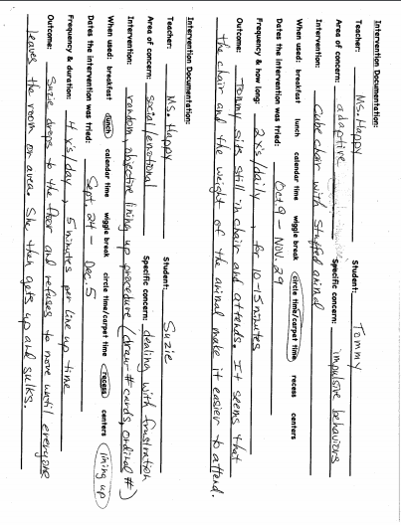

Intervention Documentation Form (example #2):

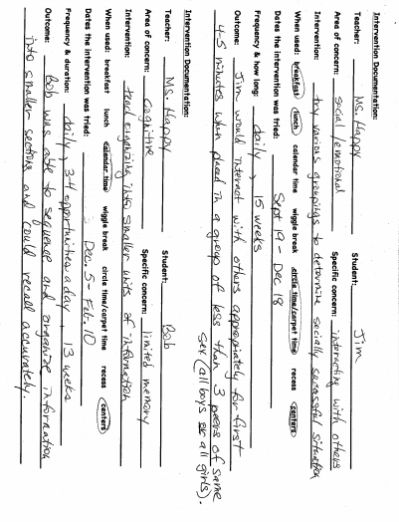

Blank Intervention Documentation Form

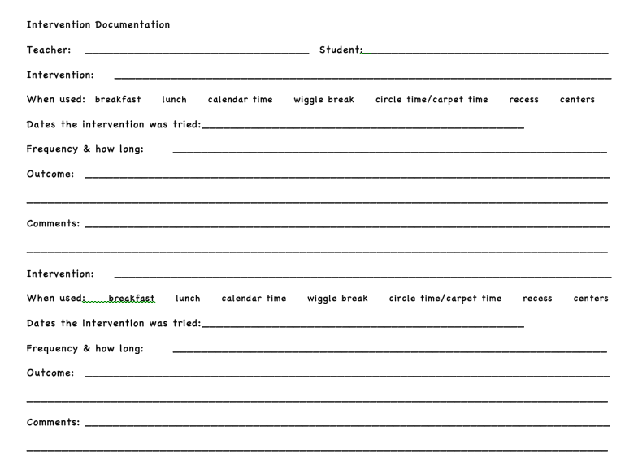

The premise of RTi is to implement interventions which could assist in avoiding unnecessary referrals for special education evaluations.

