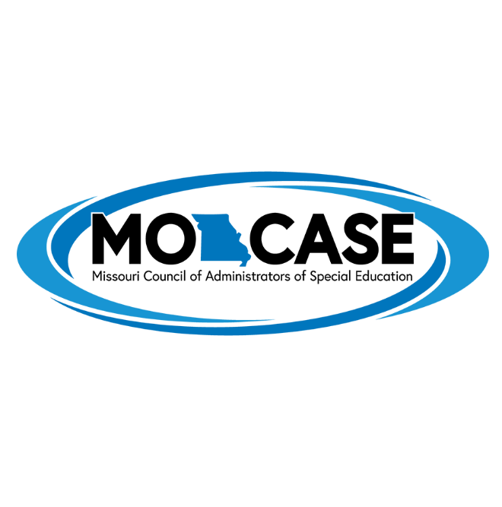

Distinguished Service Award

The MO-CASE Distinguished Service Award is presented to an individual who
- has 20 years of service in special education administration or a related field,
-has made outstanding contributions beyond those expected in an individual's job,
-has served in more than one area, such as, research, teaching, publication, administration, community
service, and
-has made statewide or national contributions or has received recognition for such contributions.
Because this criterion is so high, it is not expected that this award will be given annually.
The distinguished service award is MO-CASE’s highest honor.

