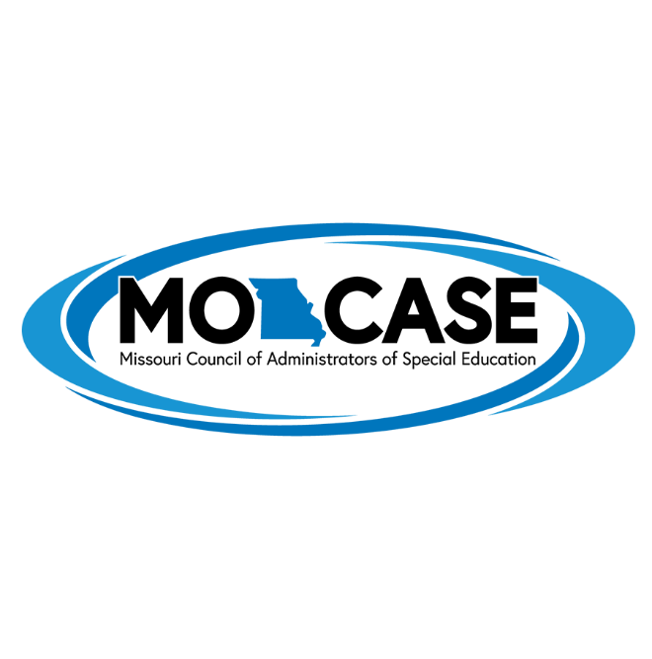

MO-CASE Recognition Award

The MO-CASE Recognition Award is designed to annually recognize and honor significant individual contributions
to the field of special education administration.
The MO-CASE Recognition Award is presented to an individual who

-has ten years of service in special education or related field, and
-has made outstanding contributions to the field of special education administration.

