This document was developed to clarify the relationship between Specially Designed Instruction, Core Instruction and Interventions within a multi-tiered system of supports (MTSS) for educators developing, improving and maintaining systems of support for all students. The reauthorization of the Individuals with Disabilities Education Act (IDEA) in 2004 made it clear that students with disabilities are to be considered first and foremost as general education students. This distinction, along with the implementation of a multi-tiered system of supports and Common Core State Standards, has prompted educators to consider the characteristics that uniquely define special education.

The graphic below illustrates the integration of specially designed instruction within an MTSS. Instruction and interventions for all students are implemented using a data-based problem-solving process that matches the intensity of support to meet student needs (both strengths and weaknesses). Effective core instruction and interventions are provided for all students, including students with disabilities, who need various levels of supports to master grade-level Common Core State Standards. Students with disabilities are legally entitled to specially designed instruction, including intensive interventions, when the intensity of their needs warrants this level of support.

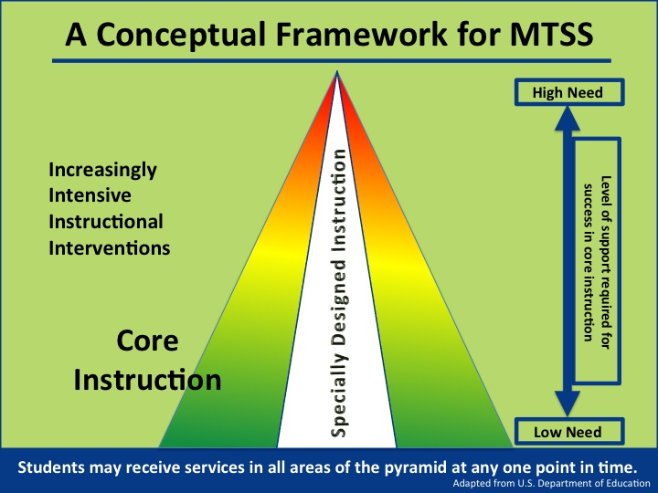

The table below provides an in-depth explanation of the similarities and differences – as well as the inter-relatedness – of Specially Designed Instruction, Core Instruction, and Interventions.
 | Specially Designed Instruction | Core Instruction  (Tier 1) | Supplemental Intervention  (Tier 2) | Intensive Intervention  (Tier 3)
 |  | –Applicable Across All Tiers–
Defining Characteristics | Specially designed instruction as defined by IDEA regulations refers to adaptations to the content, methodology or delivery of instruction that:  - Address the unique needs of a child that result from the child’s disability  - Ensure access to the general education curriculum so that the child can meet the educational standards that apply to all children (34 Code of Federal Regulations (CFR) §300.39(b)(3))  - Are guaranteed by IDEA and implemented in accordance with the individual educational plan (IEP) process | Instruction and support designed and differentiated for all students in all settings to ensure mastery of the Common Core State Standards and core instructional goals/expectations. | More focused, targeted instruction/intervention and supplemental support aligned with Common Core State Standards and core instructional goals/expectations. | The most intense* intervention based upon individual student need and aligned with core curriculum, instruction and supplemental supports.  * Daily or near daily sessions; increased time per session for delivery, practice and feedback; narrowed focus; reduced group size; most explicit and systematic; most frequent progress monitoring.
Common Focus | Provide instruction and intervention supports, designed and implemented through a team approach to data-based planning and problem solving, matched to student learning needs.
Relationship to Core Instruction | Integrated and in alignment with Common Core State Standards and core instructional goals and expectations across the full continuum of learners.
 | Specially Designed Instruction | Core Instruction  (Tier 1) | Supplemental Intervention  (Tier 2) | Intensive Intervention  (Tier 3)
 |  | –Applicable Across All Tiers–
Goal | Enable students with disabilities to be involved in and make progress in the general education curriculum (34 CFR §300.320(a)(2)(i)).  Free appropriate public education for students with disabilities in the least restrictive environment (34 CFR §300.17). | Successful mastery of Common Core State Standards and prevention of skill gaps to ensure career and college readiness. | Close skill gaps to enable successful mastery of Common Core State Standards and grade-level instructional goals and expectations for learners who are struggling in the general education curriculum and setting, while ensuring the prevention of new content area gaps and supporting student engagement.
For Whom? | Eligible students with disabilities (IDEA).  When applied at tier 3, these students typically demonstrate a need for sustained intensive interventions in order to maintain adequate rates of progress over time. | ALL students. | Any student who needs supplemental supports to master Common Core State Standards. | Any student who needs intensive supports (i.e., identified problem is both intense and severe) to master the Common Core State Standards.
By Whom? | Exceptional student education (ESE) teachers and related service providers with specialization in the area of need, in collaboration with general education teachers to align and integrate with Common Core State Standards. | General education teacher, in collaboration with school-based team members. | General education teacher in collaboration with support of school-based team members who have content knowledge and intervention expertise. | General Educators, special educators, school-based team members and professional support staff with deep content knowledge and expertise implementing evidence-based interventions.
Where Are Interventions Delivered? | Specially designed instruction is a service, not a place, and is not defined by where it occurs. Must be provided in least restrictive setting (34 CFR §300.17). | Evidence-based instruction and support provided in the general education setting.
 | Specially Designed Instruction | Core Instruction  (Tier 1) | Supplemental Intervention  (Tier 2) | Intensive Intervention  (Tier 3)
 |  | –Applicable Across All Tiers–
How Are Interventions and Services Documented? | An IEP, which may include an intervention plan that specifies details of the interventions and is aligned with the goals and services of the IEP. | Differentiated instruction is documented through the lesson – planning process. | Progress Monitoring Plan (PMP), 504 Plan, Limited English Proficient (LEP) Plan, or other intervention plans when applicable.
What Legal Protections Apply? | Procedural safeguards protect the rights of students with disabilities and their families. | No procedural safeguards unless 504 eligible.
How Are Learning Needs Accommodated? | Accommodations specified by the IEP are provided so that students with disabilities can access information and demonstrate what they know and are able to do. | No accommodations unless 504 eligible or on an LEP Plan.
How Are Students Engaged and Supported in Learning? | Universal Design for Learning, instructional scaffolds to bridge gaps and reduce or eliminate barriers to engagement, differentiation, and learning supports that reduce or eliminate barriers to learning.
What Is the Purpose of Assessment? | The purpose of assessment depends upon the specific assessment questions to address student needs.
What Assessment Practices Are Relevant? | Formative, Screening, Ongoing Progress Monitoring and Diagnostic Assessment including those required for instructional and eligibility decision making per IDEA. The frequency and depth of assessment practice increases as student need intensifies. | Formative, screening, ongoing progress monitoring and diagnostic assessment.

